Lab – 4
21BCE6061
Darshan J Patel

1. Check wheather given number is prime
Code -
#!/bin/bash

echo "Enter a number: "
read num

if [ $num -lt 2 ]
then
echo "$num is not a prime number"
exit
fi

for (( i=2; i<$num; i++ ))
do
if [ $(($num % $i)) -eq 0 ]
then
echo "$num is not a prime number"
exit
fi
done

echo "$num is a prime number"

SS

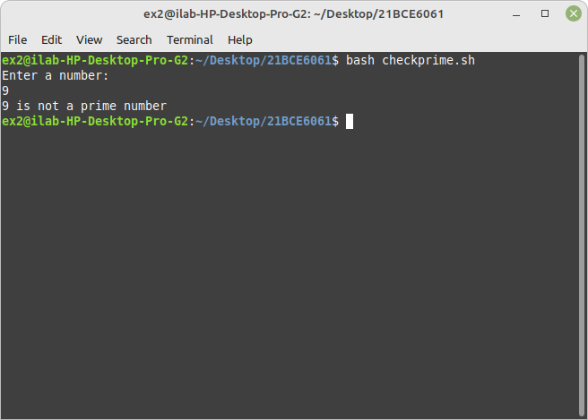
(b) find the factorial of a number
#!/bin/bash

echo "Enter a number: "
read num

factorial=1

for (( i=$num; i>=1; i-- ))
do
factorial=$((factorial * i))
done

echo "Factorial of $num is: $factorial"

SS

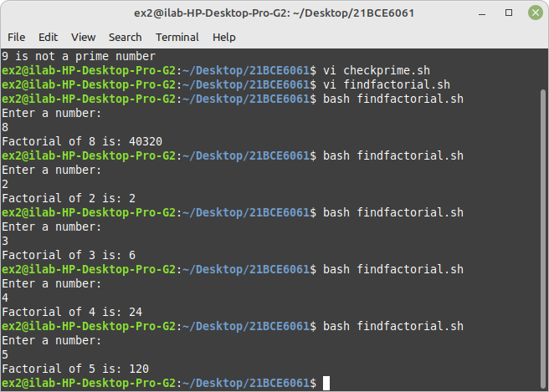
(c) find the smallest element in a array
#!/bin/bash

echo "Enter array elements: "
read -a arr

smallest=${arr[0]}

for i in "${arr[@]}"
do
if [ $i -lt $smallest ]
then
smallest=$i
fi
done

echo "Smallest element in the array is: $smallest"
SS

